**Resume OF Md. Sabbir Hossen**

|  |
| --- |
| Present Address: Uttara 17, Dhaka, Bangladesh |
| Contact No: +8801747428962 |
| Email: sabbirhosen87600@gmail.com |

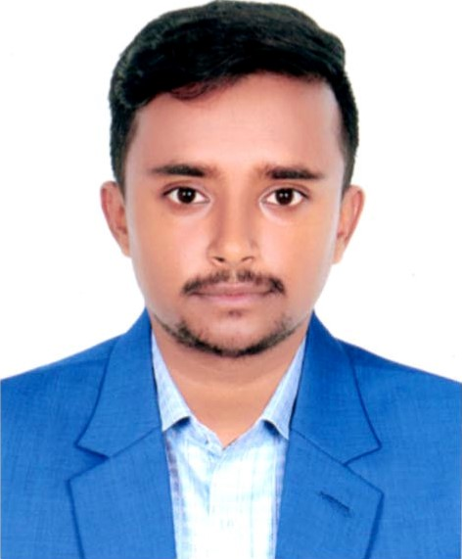

|  |
| --- |
| Career Objective |

My objective is to build up a career, which is not merely a means of living but rather a means of making life meaningful and satisfying. I believe that my academic degree will provide me with the necessary knowledge to address challenging situations at my home place and in the process, It will also help me to pursue a successful career. I want to spread my knowledge and skills to others and want to enlighten society. That is why I am willing to join them in the job sector.

|  |
| --- |
| Experience |

1. Site Supervision Engineer at Space Ten Ltd.

* Working Date:- 05-May-2020 To Continue.
* Project Name:- Khasfull & South Corner.
* Experience In High-Rise Building Construction.
* Cast In Situ Pile, Basement, Roof Slabs, Rebar Binding, & Other Construction Work Experiences.
* Cheek plans, Drawings & Quantities for accuracy of calculations.
* Ensure That all materials used and performed are in accordance with the specifications.
* Layout, Brick Masonry work, Plaster, Tiles fitting experiences.

|  |
| --- |
| Educational History |

|  |  |
| --- | --- |
| **B.Sc Engineering** |  |
| Department | Civil Engineering |
| Name Of Institution | World University of Bangladesh |
| Year Of Completion | Continue Since, May, 2021 |

|  |  |
| --- | --- |
| **Diploma Engineering** |  |
| Technology | Civil Department |
| Name Of Institution | Patuakhali, Polytechnic Institute |
| Year Of Completion | 2020 |
| Result | 3.41 ( Out Of 4 ) |

|  |  |
| --- | --- |
| **Secondary School Certificate (S.S.C)** |  |
| Broad | BTEB |
| Group | General Budling Works |
| Year Of Completion | 2016 |
| Name of Instauration | Batagi Govt. Pilot High School |
| Result | 4.75 ( out of 5 ) |

Personal Information

|  |  |
| --- | --- |
| Father Name | Kabir Hossen |
| Mother Name | Parvin Akter |
| Date of Birth | 18-Aug-1998 |
| Permanent Address | Vill: 6 No Ward, Betagi Parushava , Betagi, Barguna |
| Nationality | Bangladeshi |
| Religion | Islam |
| Sex | Male |
| Marital Status | Unmarried |
| Height | 5’-2” |
| Blood Group | AB+ |

|  |  |  |
| --- | --- | --- |
|  | Computer Proficiency | |
|  |  | |
| MS Office |  | MS word, MS Excel |
| Auto Cad |  | 2D,3D |



Md. Sabbir Hossen